SIMATS ENGINEERING VISHAL KRUTHIK

192521179

ASSESSMENT TOOL 2

COURSE NAME: Database Management Systems COURSE CODE: CSA0501

COURSE OUTCOME COVERED

CO2: Apply the relational model, relational algebra, SQL query structures, and views to solve database querying and data manipulation problems. (BL3, BL6)

Activity Tool : Scenario-Based Task (High) Assessment Tool Weightage: 35%

Dr

QUESTIONS Total Marks: 50
Q.No | Question | Bloom's Level | Marks
1 | Given the scenario of a School Management System, identify relations and write SQL to list all students with their class teacher and grade. | BL3 – Apply | 5
2 | A hospital wants to track patient appointments. Design the relational schema and write SQL to find doctors with more than 10 appointments this month. | BL3 – Apply | 5
3 | In an e-commerce scenario, write SQL queries using sub-queries to find products that have never been ordered. | BL3 – Apply | 5
4 | For a university database, write relational algebra expressions to find students enrolled in both 'DBMS' and 'OS' courses. | BL3 – Apply | 5
5 | Given a payroll scenario, create a view showing employees whose salary is below department average and write a query to update their salary by 10%. | BL6 – Create | 5
6 | In a banking scenario, apply JOIN operations to retrieve customer account details, transaction history, and branch information. | BL3 – Apply | 5
7 | A retail store needs daily sales summary. Write SQL with GROUP BY and HAVING to report total sales per category exceeding Rs. 10,000. | BL3 – Apply | 5

8 | For a library system scenario, construct tuple relational calculus expressions to find members who borrowed books from all genres. | BL3 – Apply | 5
9 | Given an inventory management scenario, define CHECK and FOREIGN KEY constraints and demonstrate their enforcement through SQL. | BL3 – Apply | 5
10 | Design a relational schema for an HR system and create materialized views for monthly attendance and performance summaries. | BL6 – Create | 5

Code of Conduct:

I VISHAL KRUTHIK 192521179certify that this submission is my original work and that I have adhered to the guidelines specified for this assessment. I understand that any violation of academic integrity rules will result in disciplinary action.

Signature of the student:


RUBRICS FOR CALCULATION:

Scenario based assessment
Criteria | Weightage (%) | Level 4 (Exemplary) | Level 3 (Proficient) | Level 2 (Developing) | Level 1 (Beginning)
Understanding of Scenario | 20% | Demonstrates clear and complete understanding of the scenario and context | Shows good understanding with minor gaps | Partial understanding; misses key aspects | Misinterprets or fails to understand the scenario
Identification of Key Issues | 20% | Accurately identifies all relevant issues and factors involved | Identifies most key issues with minor omissions | Identifies limited issues; some irrelevant points | Unable to identify key issues
Application of Concepts | 25% | Applies appropriate concepts effectively to address the scenario | Applies concepts with minor errors | Limited or partially correct application | Unable to apply relevant concepts
Decision Making | 20% | Makes well-reasoned, logical decisions with strong rationale | Makes reasonable decisions with some | Makes weak decisions with limited justification | No clear decisions made or rationale

 |  |  | justification |  | provided
Clarity of Response | 15% | Response is clear, structured, and logically presented | Generally clear with minor issues | Somewhat unclear or poorly structured | Disorganized and difficult to understand

SOLUTIONS / ANSWERS
CSA05 – Database Management Systems | Assessment Tool 2
Q1. School Management System – Relations & SQL Query
Answer 1
Identified Relations
- STUDENT (StudentID (PK), Name, Grade, ClassID (FK))
- CLASS (ClassID (PK), ClassName, Grade, TeacherID (FK))
- TEACHER (TeacherID (PK), Name, Subject)
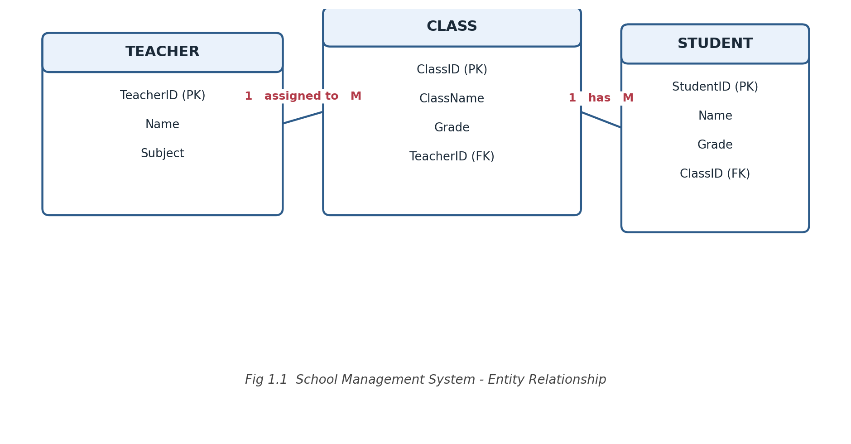
SQL Query – Students with Class Teacher and Grade
SELECT s.StudentID,
s.Name AS StudentName,
s.Grade,
c.ClassName,
t.Name AS ClassTeacher
FROM STUDENT s
JOIN CLASS c ON s.ClassID = c.ClassID
JOIN TEACHER t ON c.TeacherID = t.TeacherID
ORDER BY s.Grade, s.Name;
The query joins STUDENT to CLASS on ClassID and CLASS to TEACHER on TeacherID, returning each student alongside their grade and the name of their class teacher.
Q2. Hospital Appointment System – Schema & SQL Query
Answer 2
Relational Schema
- PATIENT (PatientID (PK), Name, Age, Gender)
- DOCTOR (DoctorID (PK), Name, Specialization)
- APPOINTMENT (ApptID (PK), PatientID (FK), DoctorID (FK), ApptDate, Status)
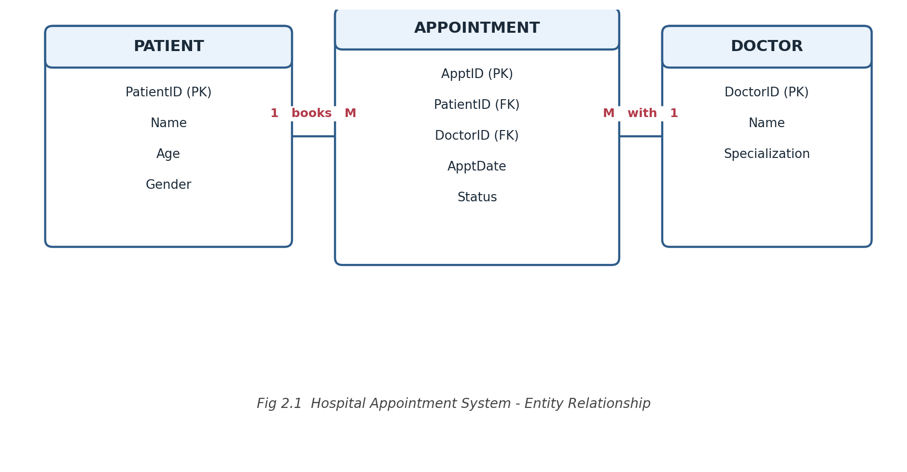
SQL Query – Doctors with more than 10 Appointments this Month
SELECT d.DoctorID,
d.Name,
COUNT(*) AS ApptCount
FROM APPOINTMENT a
JOIN DOCTOR d ON a.DoctorID = d.DoctorID
WHERE MONTH(a.ApptDate) = MONTH(CURRENT_DATE)
AND YEAR(a.ApptDate) = YEAR(CURRENT_DATE)
GROUP BY d.DoctorID, d.Name
HAVING COUNT(*) > 10;
Appointments are filtered to the current calendar month, grouped per doctor, and HAVING retains only doctors whose appointment count exceeds 10.
Q3. E-commerce – Sub-queries for Products Never Ordered
Answer 3
Relevant Relations
- PRODUCT (ProductID (PK), ProductName, Price)
- ORDER_ITEMS (OrderItemID (PK), OrderID (FK), ProductID (FK), Quantity)
SQL – Using NOT IN
SELECT p.ProductID, p.ProductName
FROM PRODUCT p
WHERE p.ProductID NOT IN (SELECT oi.ProductID
FROM ORDER_ITEMS oi);
SQL – Using NOT EXISTS (safer with NULLs)
SELECT p.ProductID, p.ProductName
FROM PRODUCT p
WHERE NOT EXISTS (SELECT 1
FROM ORDER_ITEMS oi
WHERE oi.ProductID = p.ProductID);
Both sub-queries return every product whose ProductID never appears in ORDER_ITEMS. NOT EXISTS is generally preferred over NOT IN because it is unaffected by NULL values in the sub-query's result column.
Q4. University Database – Relational Algebra (DBMS ∩ OS)
Answer 4
Relevant Relations
- STUDENT (StudentID, Name)
- COURSE (CourseID, CourseName)
- ENROLLMENT (StudentID (FK), CourseID (FK))
Relational Algebra Expression
R1 = π StudentID ( σ CourseName='DBMS' (ENROLLMENT ⋈ COURSE) )
R2 = π StudentID ( σ CourseName='OS' (ENROLLMENT ⋈ COURSE) )

Result = R1 ∩ R2
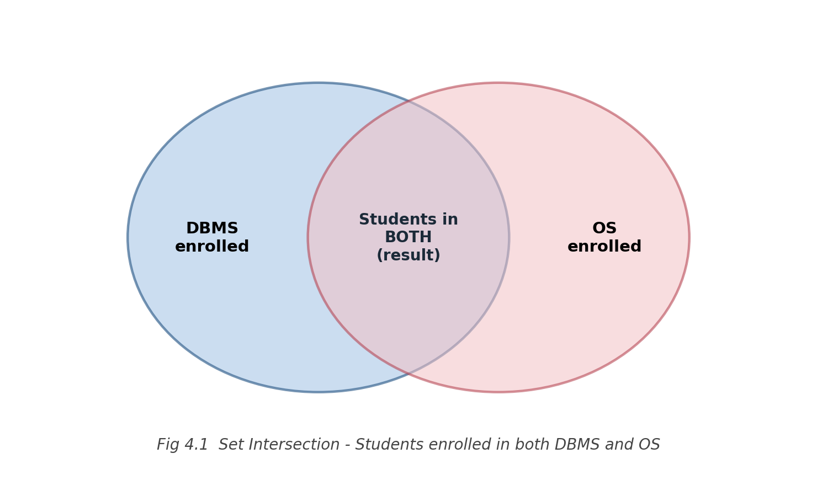
R1 selects the StudentIDs enrolled in DBMS and R2 those enrolled in OS; the set intersection (∩) of R1 and R2 gives students enrolled in both courses.
Q5. Payroll – View & Salary Update
Answer 5
Relevant Relation
- EMPLOYEE (EmpID (PK), Name, DeptID, Salary)
Step 1 – Create the View
CREATE VIEW BelowAvgSalary AS
SELECT e.EmpID, e.Name, e.DeptID, e.Salary
FROM EMPLOYEE e
WHERE e.Salary < ( SELECT AVG(e2.Salary)
FROM EMPLOYEE e2
WHERE e2.DeptID = e.DeptID );
Step 2 – Update Salary of Employees in the View by 10%
UPDATE EMPLOYEE
SET Salary = Salary * 1.10
WHERE EmpID IN ( SELECT EmpID FROM BelowAvgSalary );
The view uses a correlated sub-query to compare each employee's salary with the average salary of their own department. The UPDATE statement then raises the salary of every employee returned by that view by 10%.
Q6. Banking – JOIN Operations
Answer 6
Relevant Relations
- CUSTOMER (CustID (PK), Name, Address)
- ACCOUNT (AccNo (PK), CustID (FK), BranchID (FK), Balance)
- TRANSACTION (TxnID (PK), AccNo (FK), Type, Amount, TxnDate)
- BRANCH (BranchID (PK), BranchName, City)
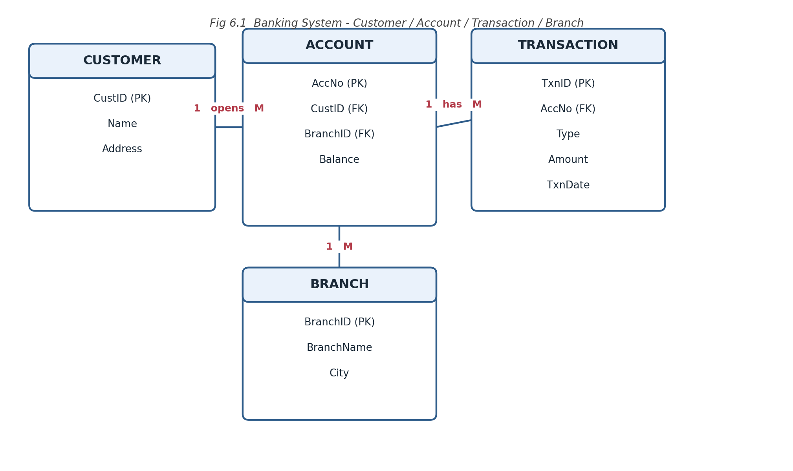
SQL – Customer, Account, Transaction and Branch Details
SELECT c.Name AS CustomerName,
a.AccNo, a.Balance,
t.TxnID, t.Type, t.Amount, t.TxnDate,
b.BranchName, b.City
FROM CUSTOMER c
JOIN ACCOUNT a ON c.CustID = a.CustID
JOIN TRANSACTION t ON a.AccNo = t.AccNo
JOIN BRANCH b ON a.BranchID = b.BranchID
ORDER BY c.Name, t.TxnDate;
Four INNER JOINs chain CUSTOMER → ACCOUNT → TRANSACTION and ACCOUNT → BRANCH so each row shows a customer's account balance, an individual transaction, and the branch where the account is held.
Q7. Retail Store – GROUP BY / HAVING Sales Summary
Answer 7
Relevant Relations
- PRODUCT (ProductID (PK), ProductName, Category)
- SALES (SaleID (PK), ProductID (FK), Quantity, UnitPrice, SaleDate)
SQL Query
SELECT p.Category,
SUM(s.Quantity * s.UnitPrice) AS TotalSales
FROM SALES s
JOIN PRODUCT p ON s.ProductID = p.ProductID
WHERE s.SaleDate = CURRENT_DATE
GROUP BY p.Category
HAVING SUM(s.Quantity * s.UnitPrice) > 10000
ORDER BY TotalSales DESC;
Sales for the day are grouped by product category; GROUP BY aggregates revenue per category while HAVING filters out categories whose total sales do not exceed Rs. 10,000.
Q8. Library System – Tuple Relational Calculus
Answer 8
Relevant Relations
- MEMBER (MemberID (PK), Name)
- BOOK (BookID (PK), Title, Genre)
- BORROW (BorrowID (PK), MemberID (FK), BookID (FK))
Tuple Relational Calculus Expression
{ m.MemberID | MEMBER(m) ∧
∀ g ( BOOK(g) →
∃ b ∃ br ( BOOK(b) ∧ BORROW(br) ∧
b.Genre = g.Genre ∧
br.BookID = b.BookID ∧
br.MemberID = m.MemberID ) ) }
This is a 'division'-style query: for every genre g that exists in BOOK, there must exist some book b of that genre that the member m has borrowed, so only members who have borrowed from every genre satisfy the universal quantifier.
Q9. Inventory Management – CHECK & FOREIGN KEY Constraints
Answer 9
Relevant Relations
- SUPPLIER (SupplierID (PK), Name, Contact)
- CATEGORY (CatID (PK), CatName)
- PRODUCT (ProductID (PK), SupplierID (FK), CatID (FK), Qty, Price)
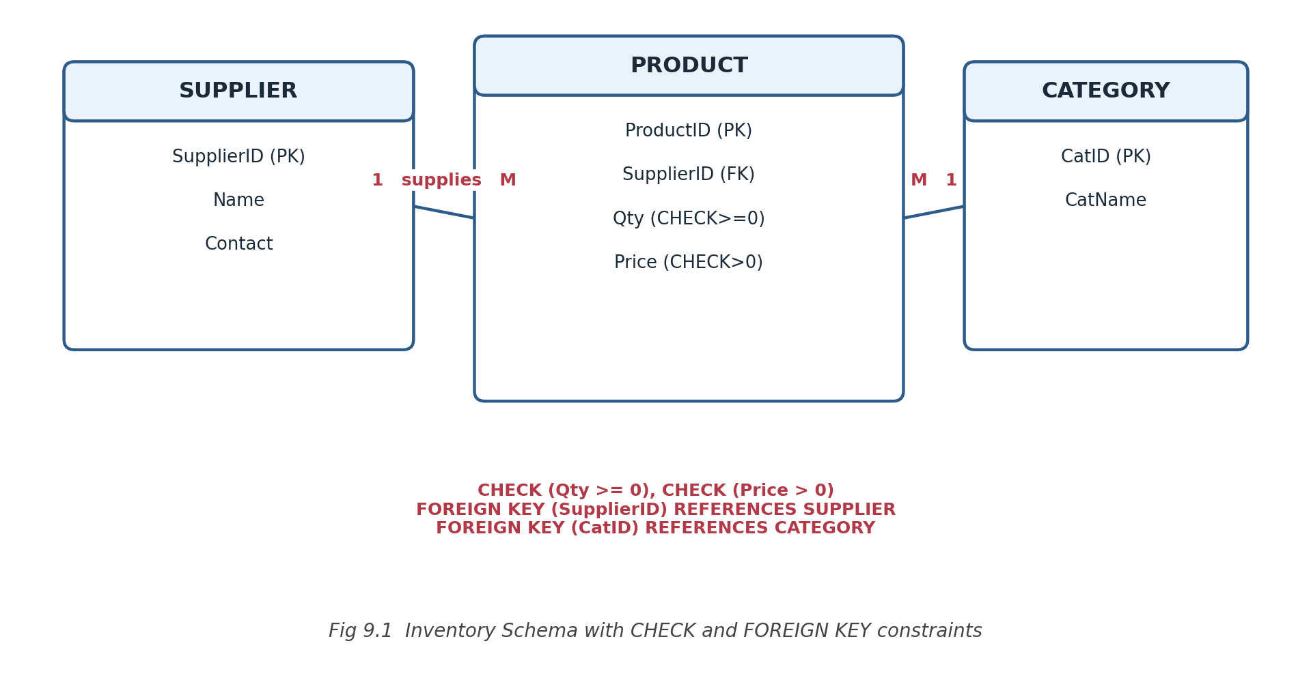
DDL with CHECK and FOREIGN KEY Constraints
CREATE TABLE SUPPLIER (
SupplierID INT PRIMARY KEY,
Name VARCHAR(100),
Contact VARCHAR(50)
);

CREATE TABLE CATEGORY (
CatID INT PRIMARY KEY,
CatName VARCHAR(50)
);

CREATE TABLE PRODUCT (
ProductID INT PRIMARY KEY,
SupplierID INT,
CatID INT,
Qty INT CHECK (Qty >= 0),
Price DECIMAL(10,2) CHECK (Price > 0),
FOREIGN KEY (SupplierID) REFERENCES SUPPLIER(SupplierID),
FOREIGN KEY (CatID) REFERENCES CATEGORY(CatID)
);
Demonstrating Enforcement
-- Violates CHECK (Qty >= 0) -> rejected
INSERT INTO PRODUCT VALUES (101, 1, 1, -5, 250.00);

-- Violates FOREIGN KEY (no SupplierID = 99) -> rejected
INSERT INTO PRODUCT VALUES (102, 99, 1, 10, 250.00);

-- Satisfies all constraints -> accepted
INSERT INTO PRODUCT VALUES (103, 1, 1, 10, 250.00);
The CHECK constraints stop negative stock or non-positive prices from being stored, while the FOREIGN KEY constraints ensure every PRODUCT row references an existing SUPPLIER and CATEGORY row.
Q10. HR System – Schema & Materialized Views
Answer 10
Relational Schema
- EMPLOYEE (EmpID (PK), Name, DeptID, Designation)
- ATTENDANCE (AttID (PK), EmpID (FK), Date, Status)
- PERFORMANCE (PerfID (PK), EmpID (FK), Month, Rating)
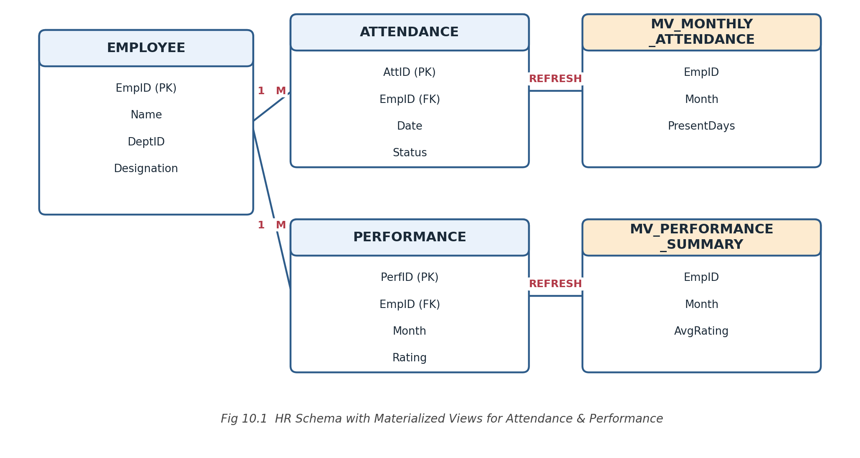
Materialized View – Monthly Attendance Summary
CREATE MATERIALIZED VIEW MV_Monthly_Attendance AS
SELECT EmpID,
TO_CHAR(Date, 'YYYY-MM') AS Month,
COUNT(*) AS PresentDays
FROM ATTENDANCE
WHERE Status = 'Present'
GROUP BY EmpID, TO_CHAR(Date, 'YYYY-MM');
Materialized View – Performance Summary
CREATE MATERIALIZED VIEW MV_Performance_Summary AS
SELECT EmpID, Month,
AVG(Rating) AS AvgRating
FROM PERFORMANCE
GROUP BY EmpID, Month;

-- Periodic refresh (e.g. scheduled monthly)
REFRESH MATERIALIZED VIEW MV_Monthly_Attendance;
REFRESH MATERIALIZED VIEW MV_Performance_Summary;
The two materialized views pre-compute and physically store monthly attendance counts and average performance ratings per employee, giving fast read access for HR reports without re-aggregating the base tables each time; they are periodically refreshed to stay current.

